
Estd.2000
Swami Devi Dyal Law College

Presents

3rd NATIONAL MOOT COURT COMPETITION, 2021

15th - 16th July, 2021

ABOUT THE GROUP
Swami Devi Dyal Hi-Tech Educational Academy is located at the foot hills of Shiwalik Range and surrounded by Natural Green Habitat and value based professional education to the youth so that they contribute to the national, economic and social growth.

ABOUT THE COLLEGE
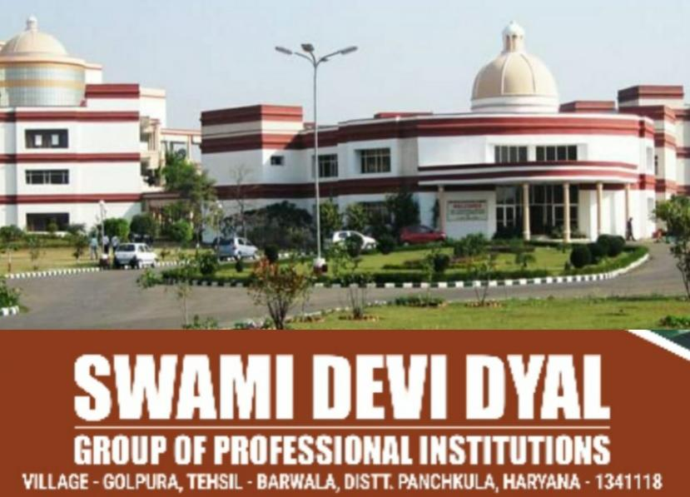
Swami Devi Dyal Law College started functioning in 2007-2008. The ambiance and serenity of this Law College provides a healthy environment for the studies. The college has highly qualified, experienced and vibrant teaching faculty which provides an excellent blend of rigger and relevance in teaching. Students touch the lives of wide cross section of society by visiting old age home and villages. Students and faculty actively participate in outreach program where they contribute their knowledge and provide technical expertise to community by visiting school and colleges.

PATRONS
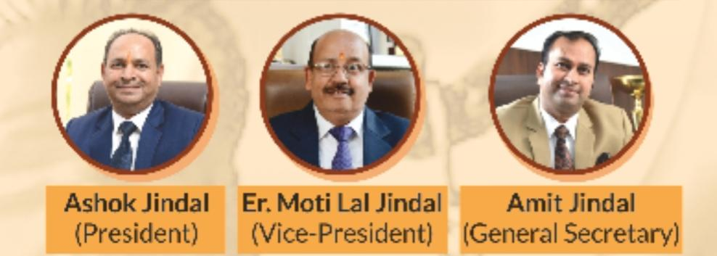

ORGANIZER
- Dr. Richa Ranjan
(Director-Principal)
Swami Devi Dyal Law College

ABOUT THE MOOT COURT COMPETITION

Moot Court Competition is a form of an oral proceeding similar to that of a court proceeding practiced to see that how efficient a student is in making an argument based on law.
With current unprecedented times looming over the economy, there is need to call out all the stakeholders to act pro-actively. With change in the daily activities, there has arisen a steadfast need for complete technological shift. This shift also includes change in how education and related academic activities must be administered. Online Learning has become the new normal and students and professionals around the Globe are becoming more and more accustomed to it. In order to Aid this online Moot Court Competition is being organised.
The objective of the Moot Court Competition is to develop the academic and advocacy excellence among students and inculcating the spirit of leadership and teamwork, leading to academic and professional excellence. In this competition a proper court scenario is created where the students act like the Councilors (Advocates) presenting each side (Plaintiff and Defendant) on the basis of evidences and substantive questions of law argue with each other to prove their point in front of the judge who in the end will give his judgment in the same regard and will also declare the winner who has performed the best.

REGISTRATION
All interested teams shall, first, register themselves by filling the Registration Form latest by
5th June, 2021, 11:59 P.M.

by clicking the link:-
https://docs.google.com/forms/d/e/1FAIpQLSe9GKjj_u7ilN-kfUwSvvZPFjbrH0pRGVG1_K1BvwWjfI31Ug/viewform?usp=sf_link
or
by scanning this QR code:-


FEES
Rs 500/- per team (To be deposited within stipulated time as per rules.)

MODE OF PAYMENT

Mode of payment of the registration fees shall be via Google Pay only to be made on following no. :- 9996330015.

*In case of any confusion participants can call at this Mobile No. before payment.
*After payment transaction details must be shared at sddlcmootcourtcompetition@gmail.com

AWARDS AND CERTIFICATES
- BEST TEAM
- RUNNER-UP
- BEST PETITIONER/PROSECUTION MEMORIAL
- FIRST RUNNER UP PETITIONER/PROSECUTION MEMORIAL
- SECOND RUNNER UP PETITIONER/PROSECUTION MEMORIAL
- BEST RESPONDENT/DEFENCE MEMORIAL
- FIRST RUNNER UP RESPONDENT/DEFENCE MEMORIAL
- SECOND RUNNER UP RESPONDENT/DEFENCE MEMORIAL
- BEST ORATOR
- BEST RESEARCHER
- CERTIFICATE OF PARTICIPATION WILL BE GIVEN TO ALL PARTICIPANTS.

KEY DATES

Event | Date
Notification of competition & release of moot proposition | 20th April, 2021
Last date for Registration | 5th June, 2021, 11:59 p.m.
Last date of submission of soft copy of memorials | 30th June 2021, 11:59 p.m.
Preliminary & Quarter Final rounds | 15th July, 2021
Semi Final & Final Round | 16th July , 2021

CONDUCT OF COMPETITION
- The Competition will be conducted by using online live video conferencing platform. The details of the platform shall be shared to the teams via mail.
- To ensure the smooth functioning of the competition, in adherence to the rules of Social Distancing and Government Guidelines, all participants will participate from their respective places. No team shall be seated together for the purpose of the Competition.
- An Invitation link of the meeting shall be sent to participants on their respective email IDs submitted by them in Registration Form and through WhatsApp prior to each round.
- Following are the mandatory system requirements to participate in the competition:
  - Computer/Laptop with a well configured web cam.
  - A stable Internet Connection with speed more than 5 MBPS.
  - Headphones or Earplugs that have a working microphone.
- The organizers shall have the rights reserved over all the audio, video or submitted memorials and compendium and the organizers are free to use or dispose them off in the manner they deem fit.

FOR FURTHER DETAILS CONTACT

Organizing Committee:
Dr. Gurdeep Kaur (Assistant Professor) - 8901459977
Ms. Nidhi Kathuria(Assistant Professor)- 7015776072
Ms. Pratibha Sainsaith ( Assistant Professor) - 9878037166

E-mail:-
sddlcmootcourtcompetition@gmail.com

Glimpses of Moot Court Competitions
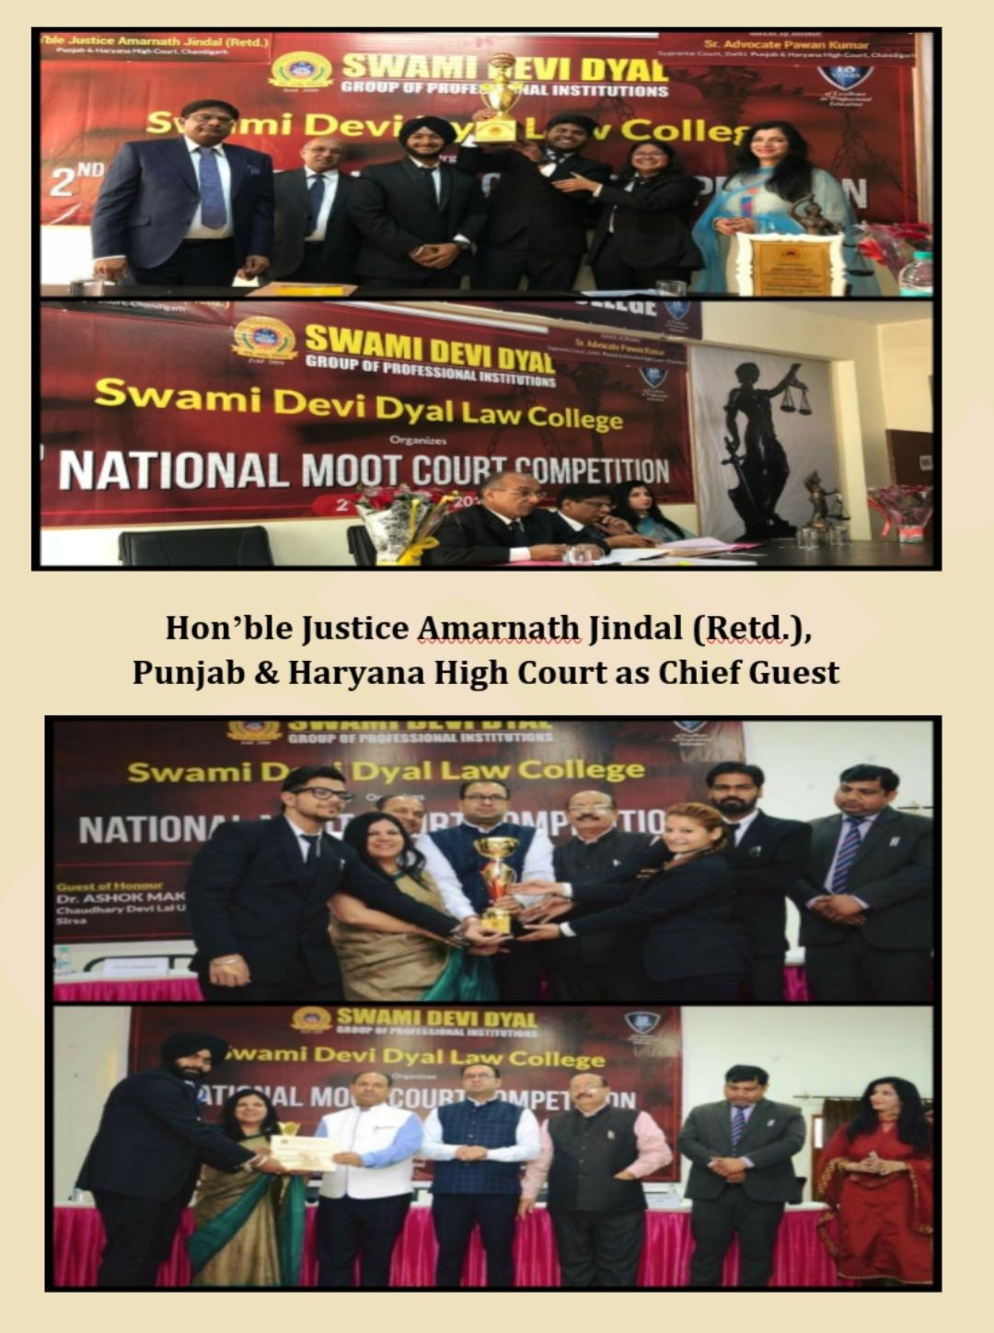
Chief Judicial Magistrate, Nidhi Bansal,
District Courts Panchkula as Chief Guest

